Professional High School

**SECOND QUARTER**

**ICT 9** SEATWORK 1: CSS Text Properties



**DIRECTIONS:**

1. Create a webpage about dog breeds.
2. Insert the following HTML elements:

* Images
* Tables
* Links

1. Apply CSS text properties to design your output.
2. Save your files following the format: **CAMPUS_ICT9Section_Q2SW1_LastName_FirstName.html**
3. Add your references in APA format.
4. Upload your webpage in GitHub.
5. Submit your website link in ICT VN.

**SAMPLE OUTPUT:**

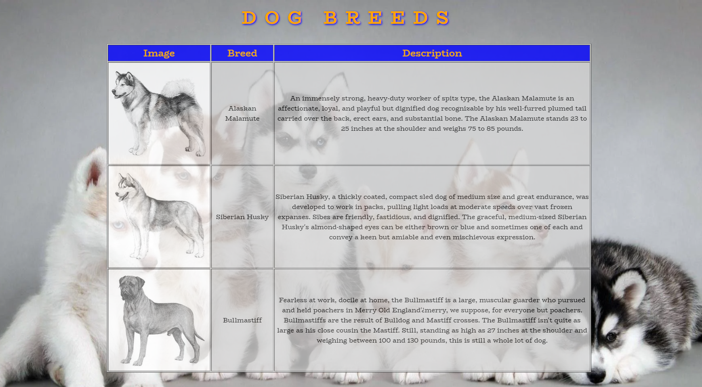

**Scoring Rubric**

|  |  |  |  |  |  |
| --- | --- | --- | --- | --- | --- |
|  | **E =5** | **AS = 4** | **S = 3** | **NI = 2** | **P = 1** |
| **Execution of Instructions** | Executed the instructions efficiently. Followed the procedures accurately. | Followed most of the instructions. One instruction is skipped; however, it does not affect the over-all output. | The activity shows the basic HTML structure.  There are two to three errors in the activity. | The activity is missing important contents due to omission of four to five instructions. | The activity is full of technical errors due to misinterpretation of all instructions. |
| **Syntax and Content** | All the contents are organized and presented in a uniform format with distinctions between major contents and supporting details. | Most contents are organized and well presented. Formatting where necessary is applied. However, one formatting requirement is missing. | The major contents are formatted; however, two to three formatting requirements are missing. | The activity contains formatting; however, four to five formatting requirements are missing. | The activity was laid out poorly. Contents are not placed in proper order. All formatting requirements are missing. |
| **Accomplished task within the time limit** | The activity was completed before the allotted time elapsed. | The activity was completed within the given time. | The activity was not completed within the given time. A five-minute extension was given in order to complete the activity. | The activity was not completed within the given time. A ten-minute extension was given in order to complete the activity. | The activity was not completed within the given time. A fifteen-minute extension was given in order to complete the activity. |
| **General Output**  (Format / Layout, Creativity / Originality) | Pre-planning and proper execution are very evident.  All requirements for the activities are evident in the final output. | The activity contains one minimal inaccuracy observed; however, it did not affect the overall output.  Applies original design in most aspect of the activity. | Two to three major components of the activity are missing.  The activity is presented with some unique design details. | The activity is very simple and lacks effort in most areas. Four to five components of the activity are missing.  Lacks originality. Design is a duplicate of the sample. | The activity has no impact at all. All major components of the activity are missing.  Failed to create even the simplest design for the activity. |
| **TOTAL** | **20** | **16** | **12** | **8** | **4** |

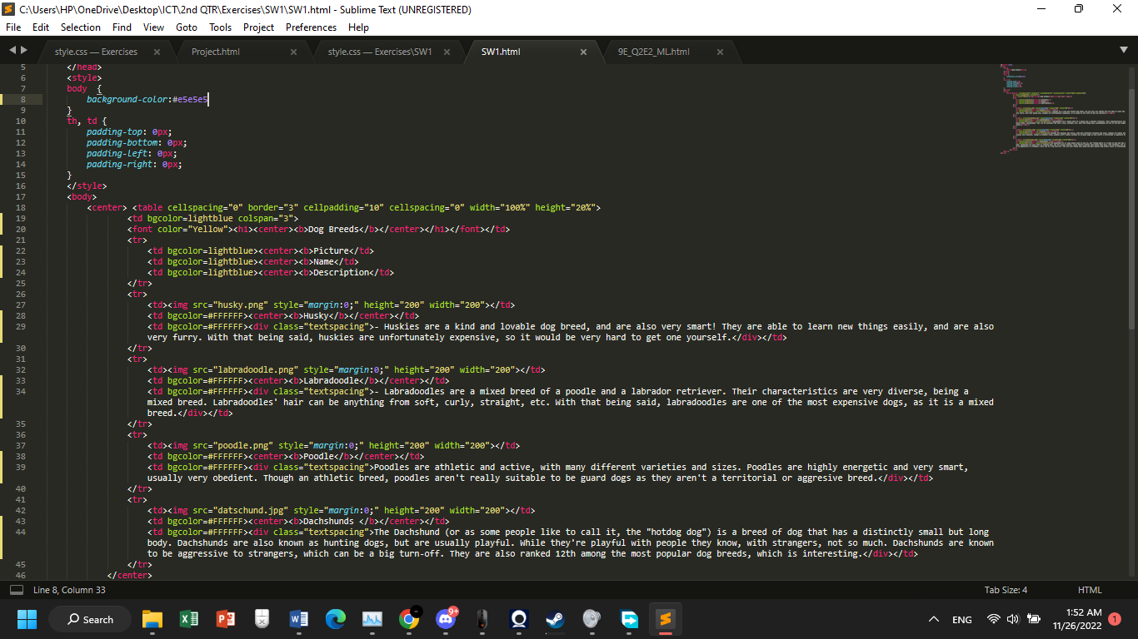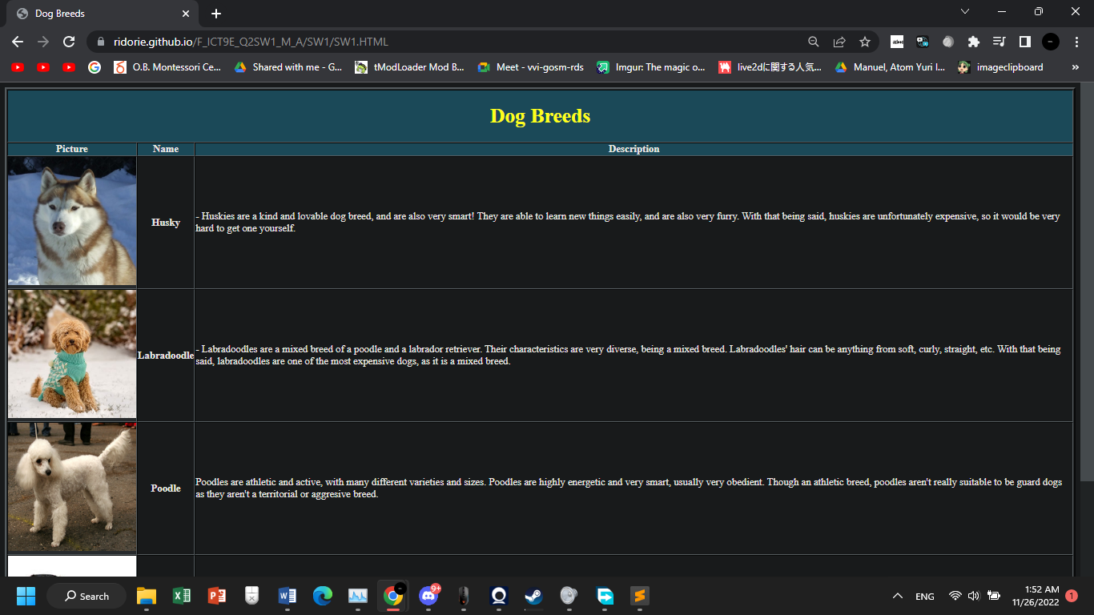

Sources:  
*1. Miniature Poodle*. (n.d.). smalldogbreeds101.com. <https://smalldogbreeds101.com/miniature-poodle.html>

2. *Puppy to Adult Pictures*. (n.d.). sweetmaplelabradoodles.com. <https://sweetmaplelabradoodles.com/why-australian-labradoodles/>

3. *Miniature Dachshund*. (n.d.). petbarn.com.au. <https://www.petbarn.com.au/petspot/dog/dog-breeds/miniature-dachshund/>

4. *Huskys Siberianos*. (n.d.). todosobrehuskysiberianos.blogspot.com. <https://todosobrehuskysiberianos.blogspot.com/2012/05/apariencia-general-el-husky-siberiano.html>